**INFO 6205**

**Program Structures & Algorithms**

**Fall 2020**

**Assignment No**

* **Task**
* **Output** (few outputs to prove relationship)
* **Relationship conclusion**
* **Evidence to support relationship** (screen shot and/or graph and/or spreadsheet)
* **Screenshot of Unit test passing**

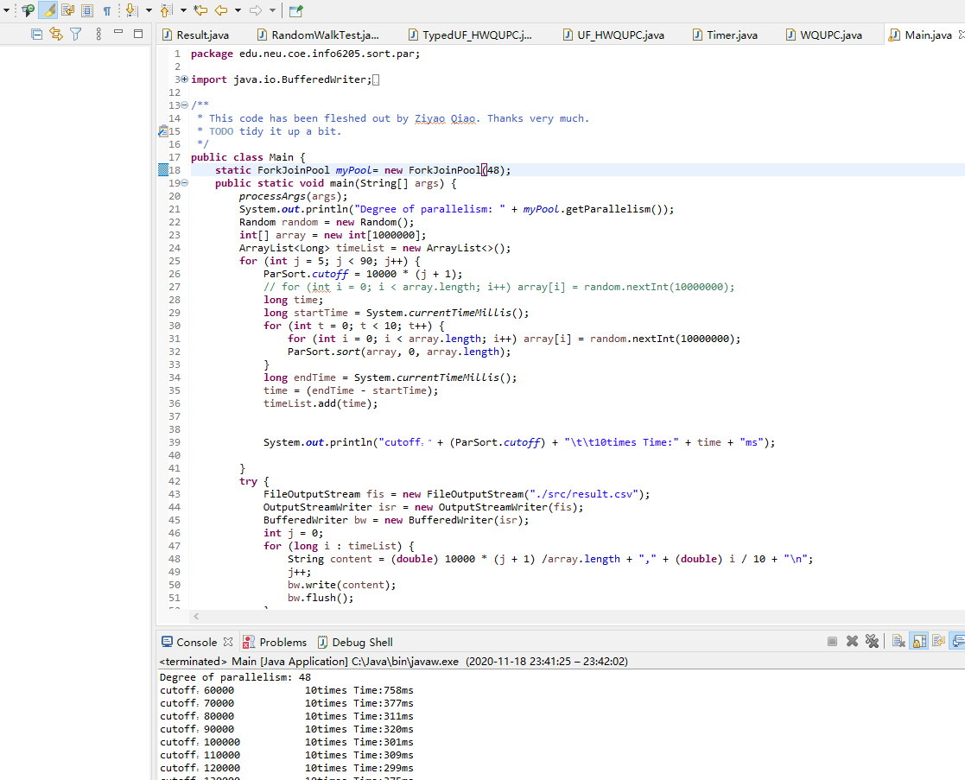

**This picture is proof of my program's success.**

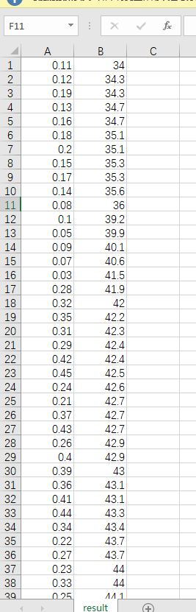 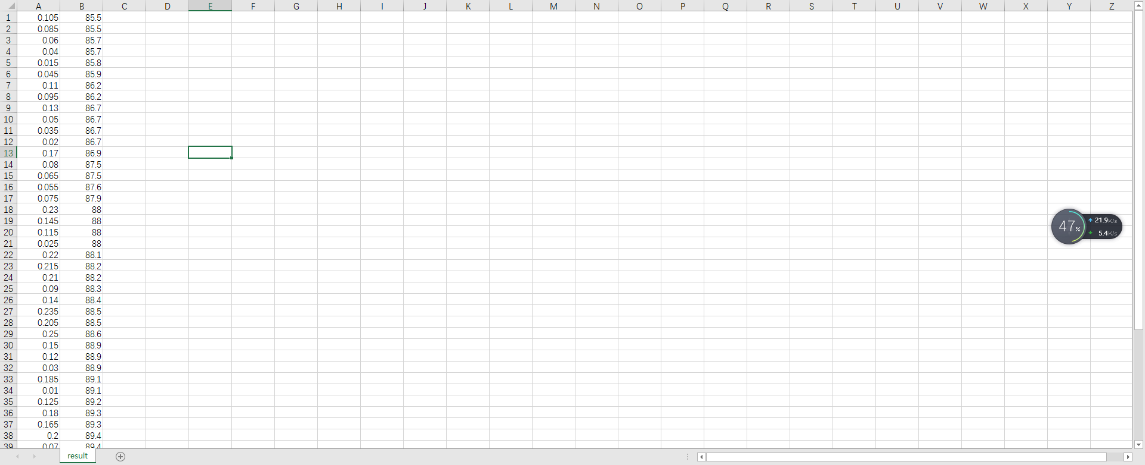 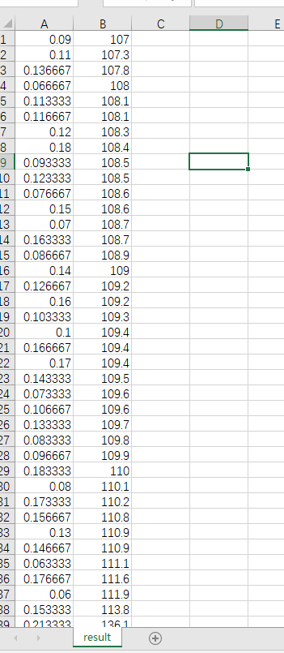 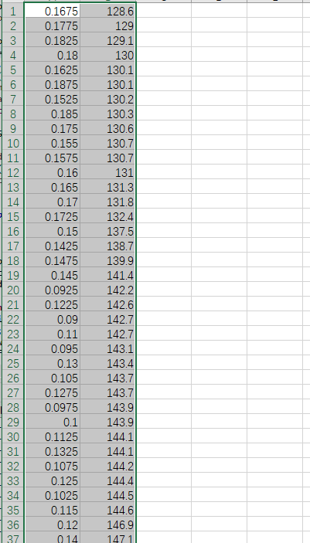 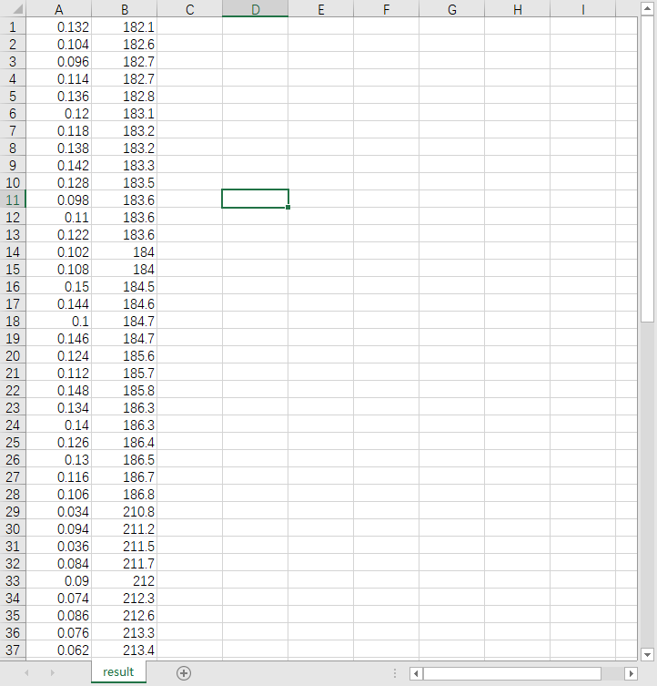

**I set the numbers of array to 1 million,2 million,3 million,4 million and 5 million, then ran the program and took a screenshot of the result from the excel.**

**Looking at the data in these lists, you can see that the top five Numbers are always around 0.1. So， you can approximately think of the relationship between cutoff and Array as 0.1.**

**Then we explore the impact of threads on runtime at 0.1.**

**So, I chose 8,16,32,48, and 64 threads to test the program.**

**And draw the conclusion from the following picture.**

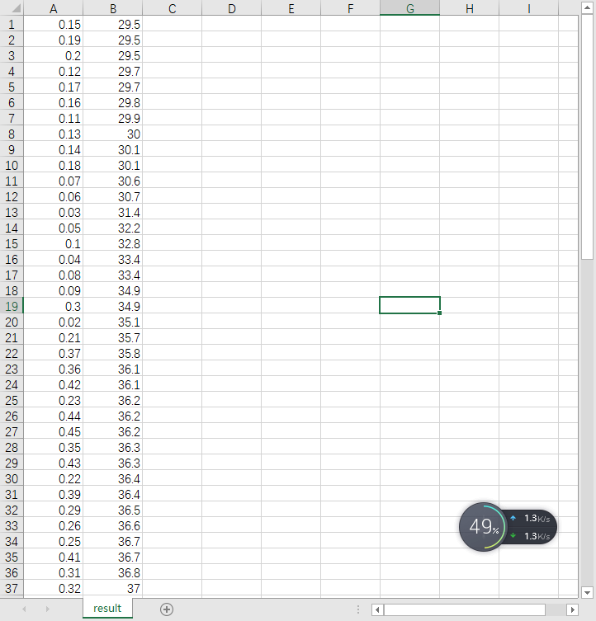

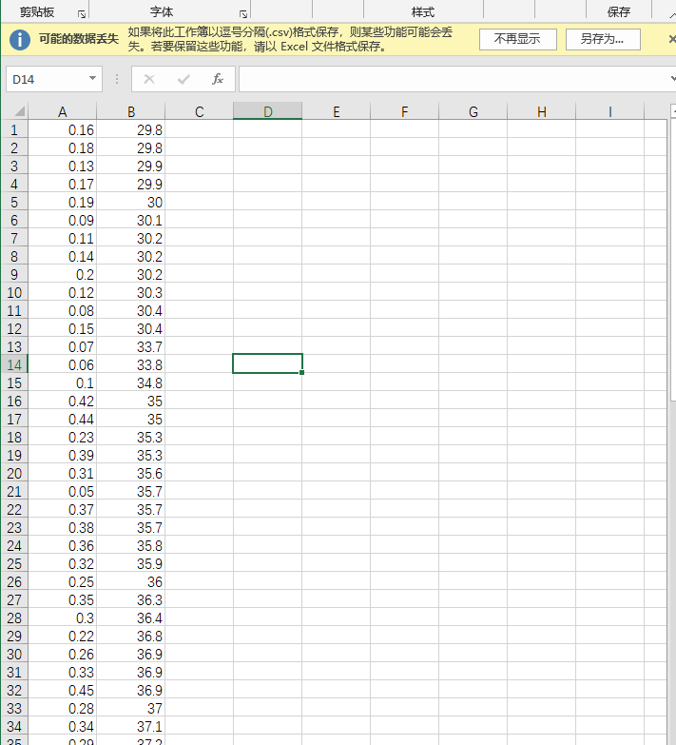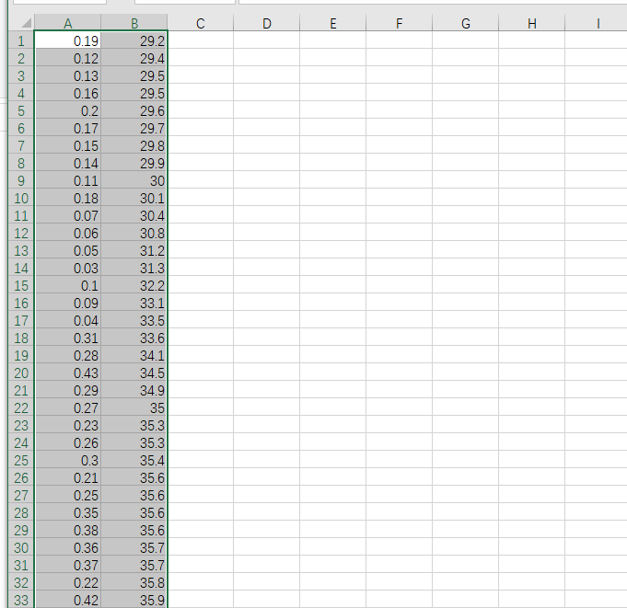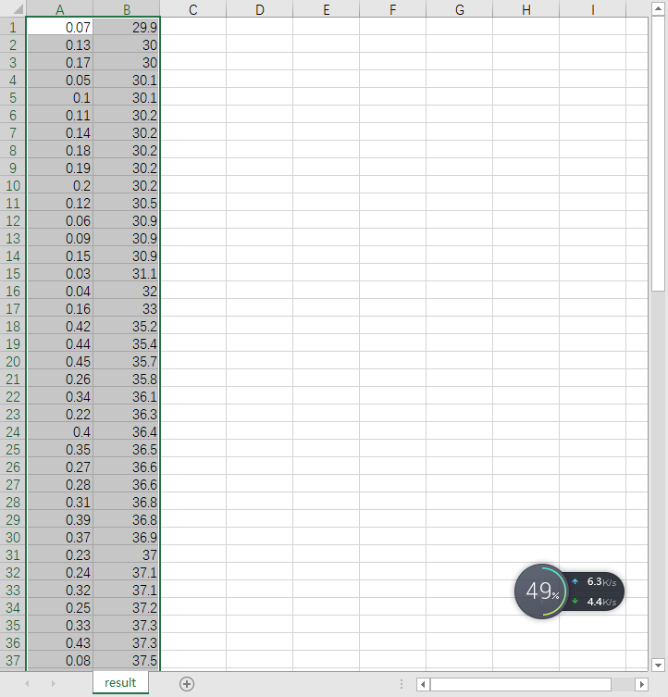

As you can see, 30.1 is the minimum for 32 threads.